# MPA Roster Application - User Guide

This guide provides a comprehensive overview of the features available in the MPA Roster Application. Follow the instructions below to navigate and utilize the system effectively.

## Accessing the System
To enter the application, navigate to the login page. Enter your unique **User ID** and **Password** into the respective boxes and click the "Login" button. Once authenticated, you will be directed to the Overview page, which serves as your central dashboard. To exit the system at any time, click the "Logout" button located at the bottom of the sidebar.
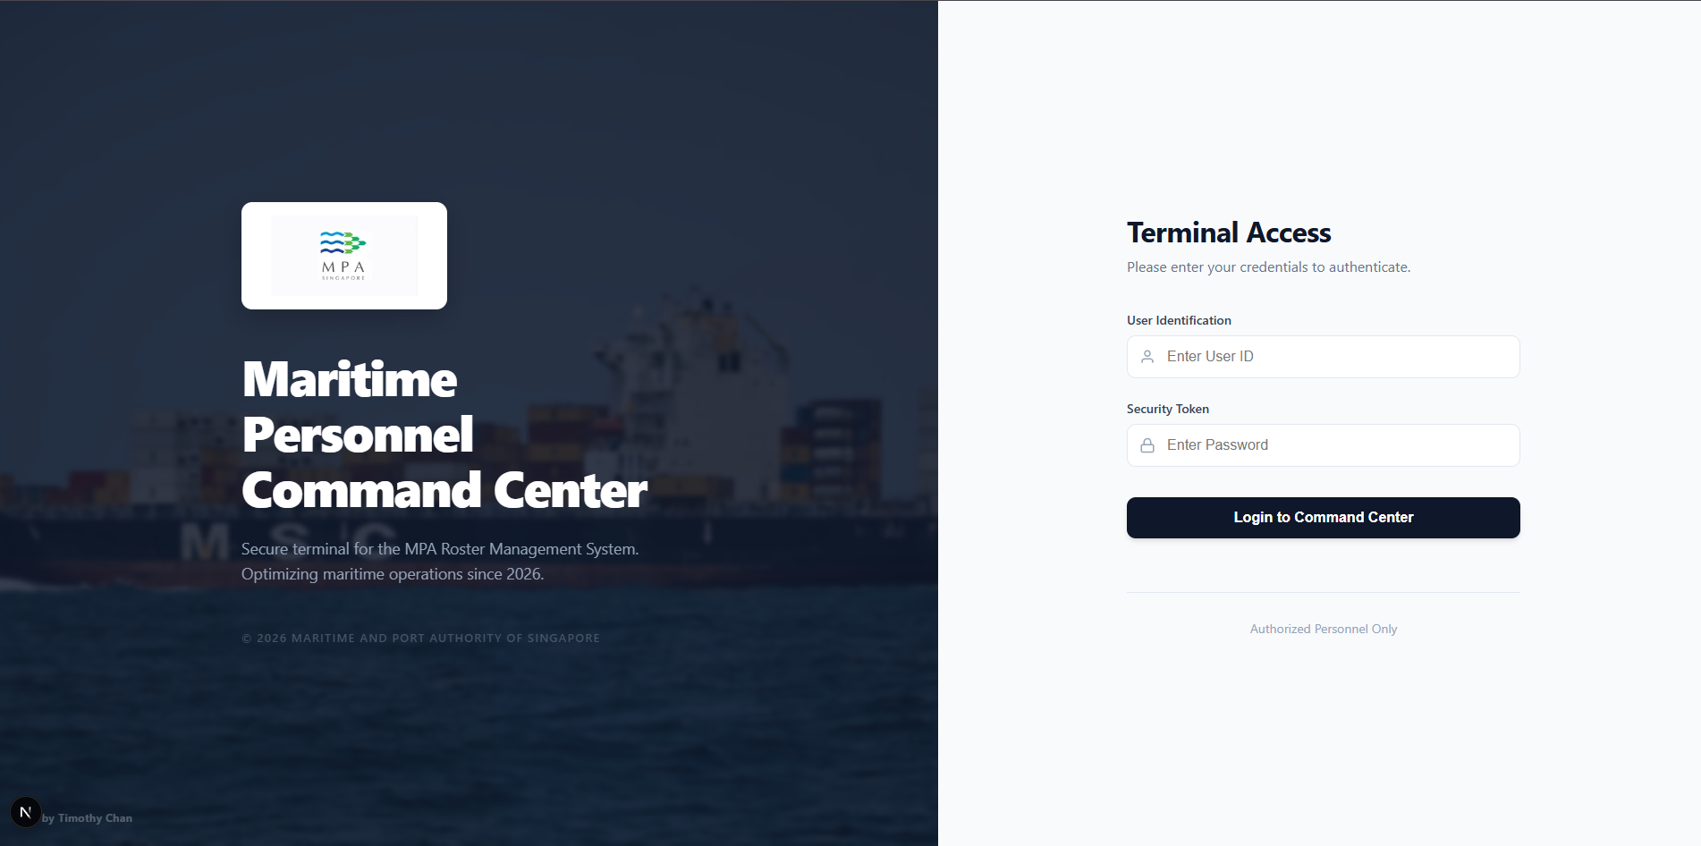
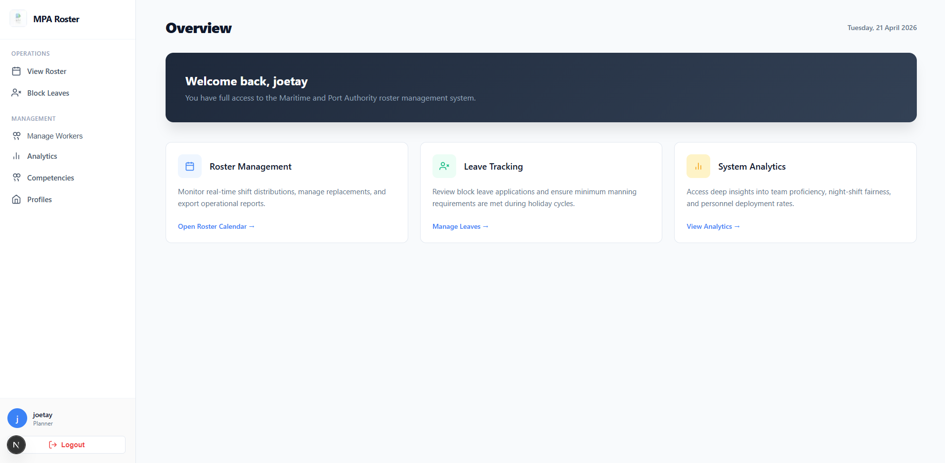
## Roster Calendar and Matrix View
The Roster page allows you to monitor shift distributions. You can toggle between **Calendar View** and **Matrix View** using the buttons at the top. In Calendar View, click on any day to see a summary of shifts. In Matrix View, you can see a grid of staff members and their assignments; click on a specific cell to view detailed shift information, including the assigned console and whether it is an On-the-Job Training (OJT) shift. Use the **<** and **>** buttons to navigate between different months.
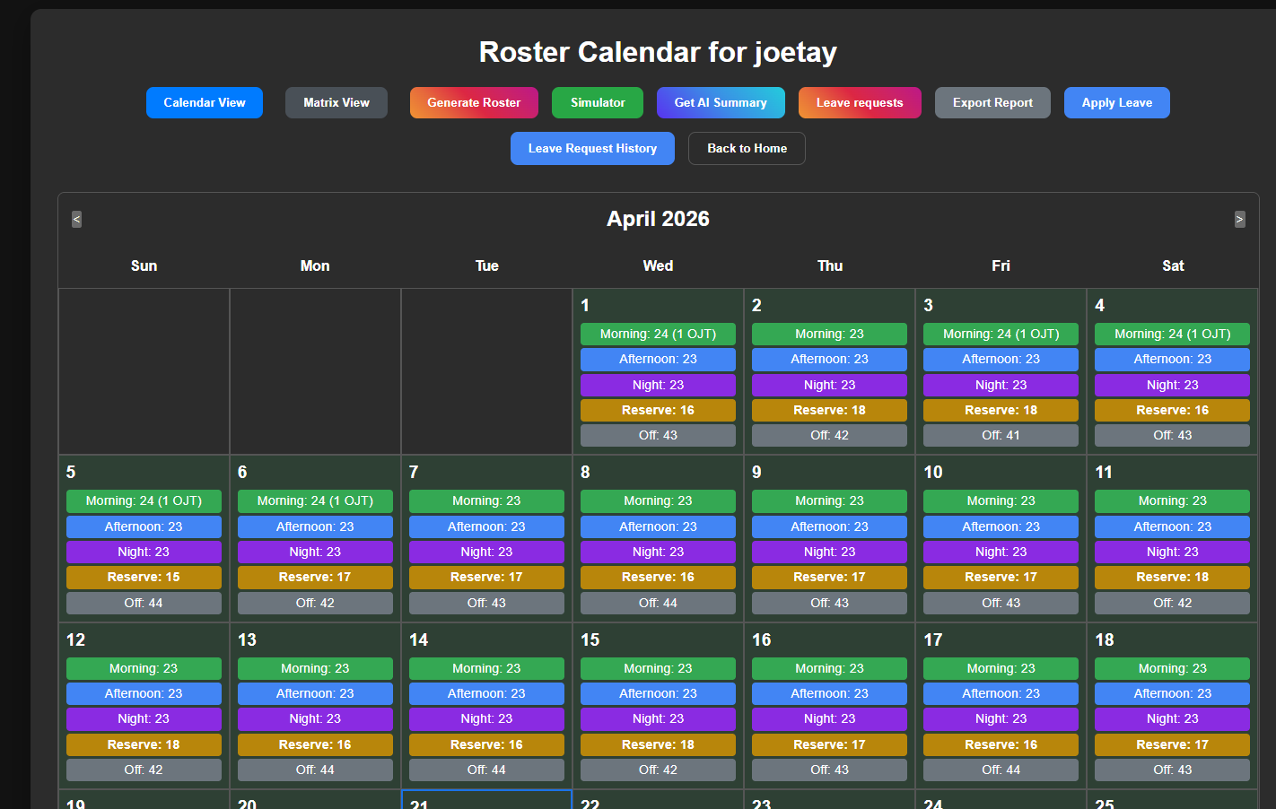

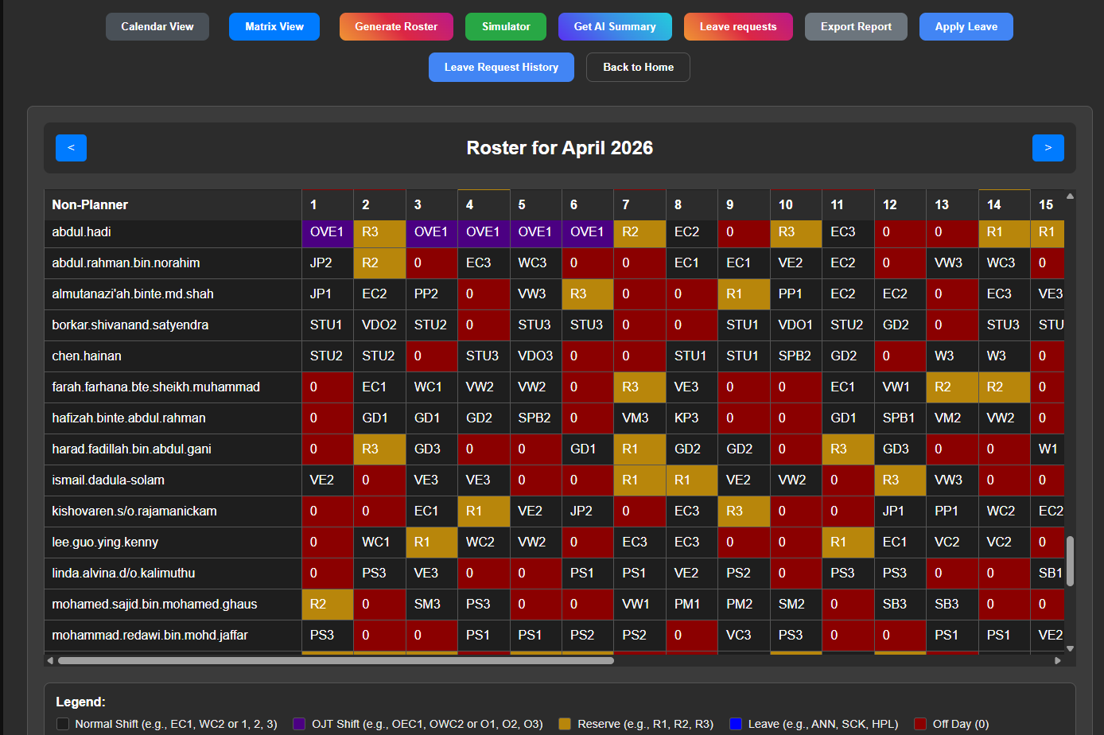
## Generating and Simulating Rosters (Planner Only)
Planners can automate roster creation by clicking "Generate Roster." In the pop-up, select the target **Month** and **Year**, then click "Generate" to create a draft. The "Simulator" feature allows you to test different staffing scenarios; input the desired parameters like **Date Range** and **Staff Constraints** to see how the system handles various requirements without affecting the live roster.
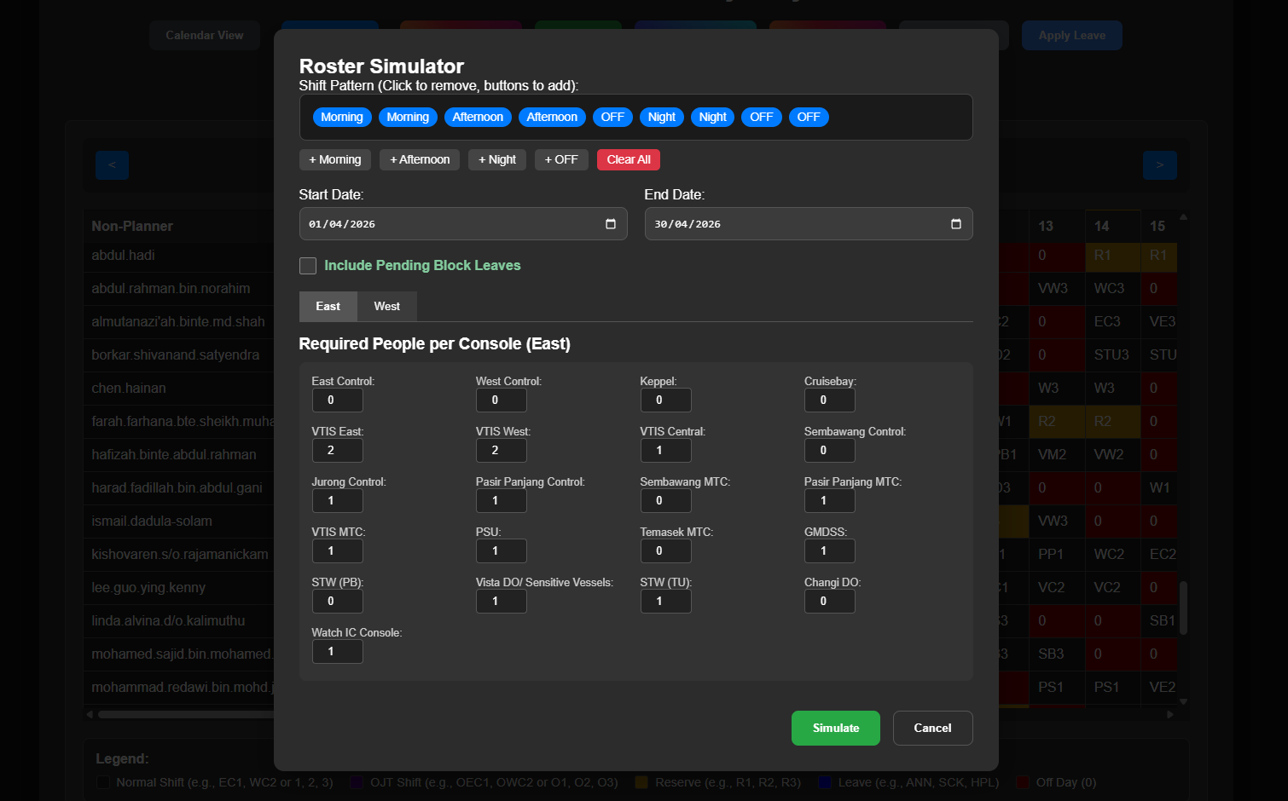

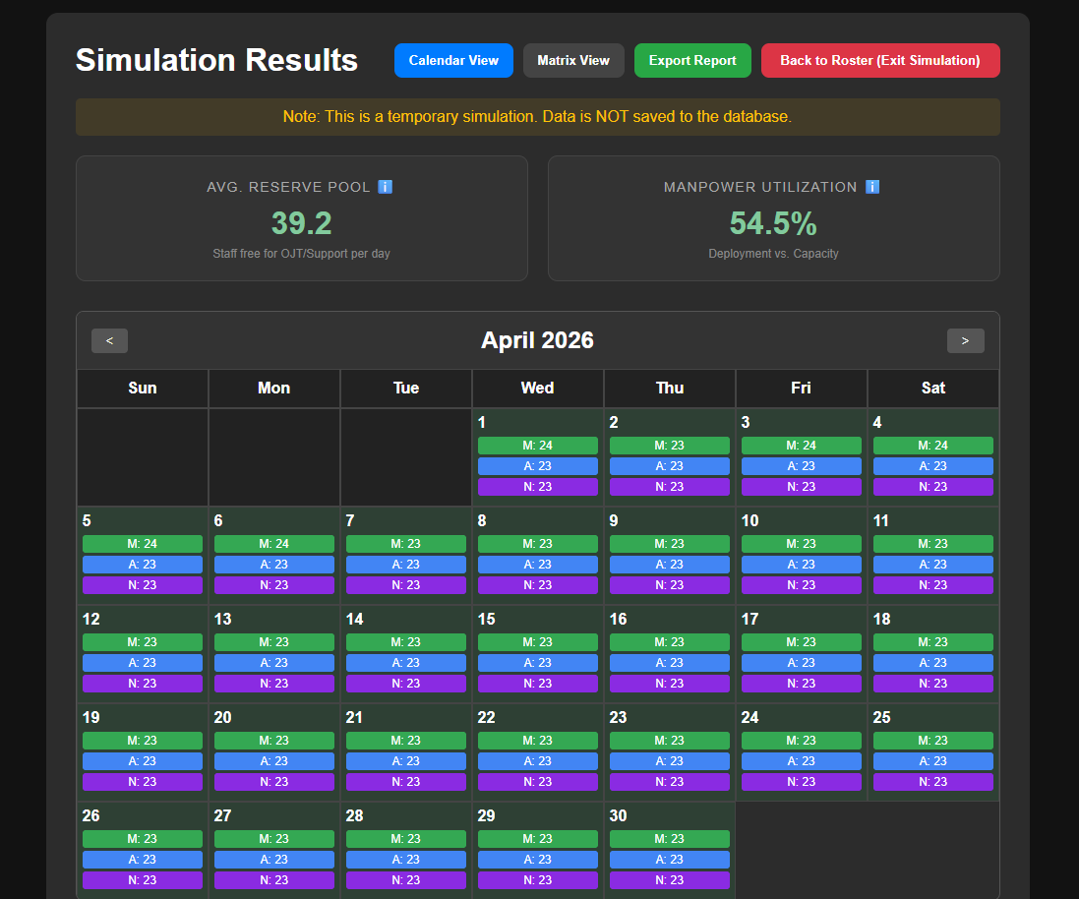
## Exporting Operational Reports (Planner Only)
To download roster data for external use, click the "Export Report" button. You will be prompted to select the **Date Range** (Start Date and End Date) and the **Format** (such as Excel or CSV). Click "Export" to save the file to your computer. This is useful for sharing schedules with team members who do not have system access.
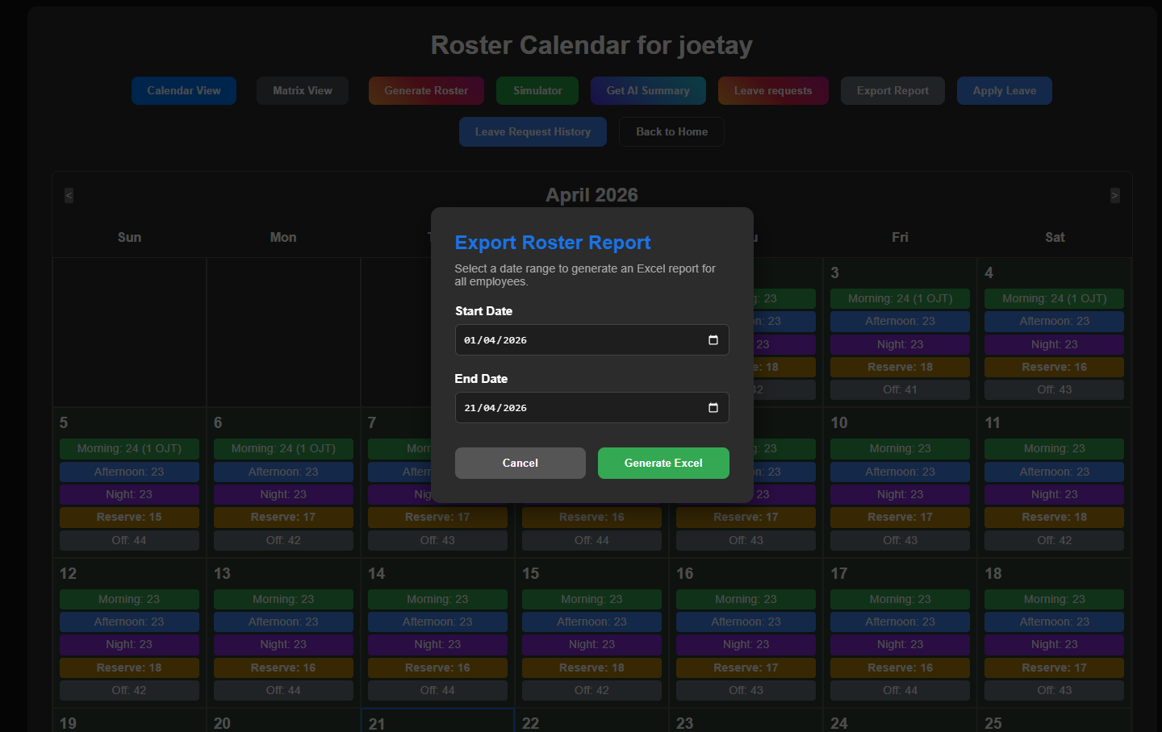
## Applying for Standard Leave
To request time off, click the "Apply Leave" button. In the form, select the **Leave Type** (e.g., Annual, Medical, Compassionate) from the dropdown menu, choose the **Start Date** and **End Date** using the calendar pickers, and provide any **Remarks** or reasons in the text box. Click "Submit" to send your request for approval. You can view your past requests and their status by clicking "Leave Request History."
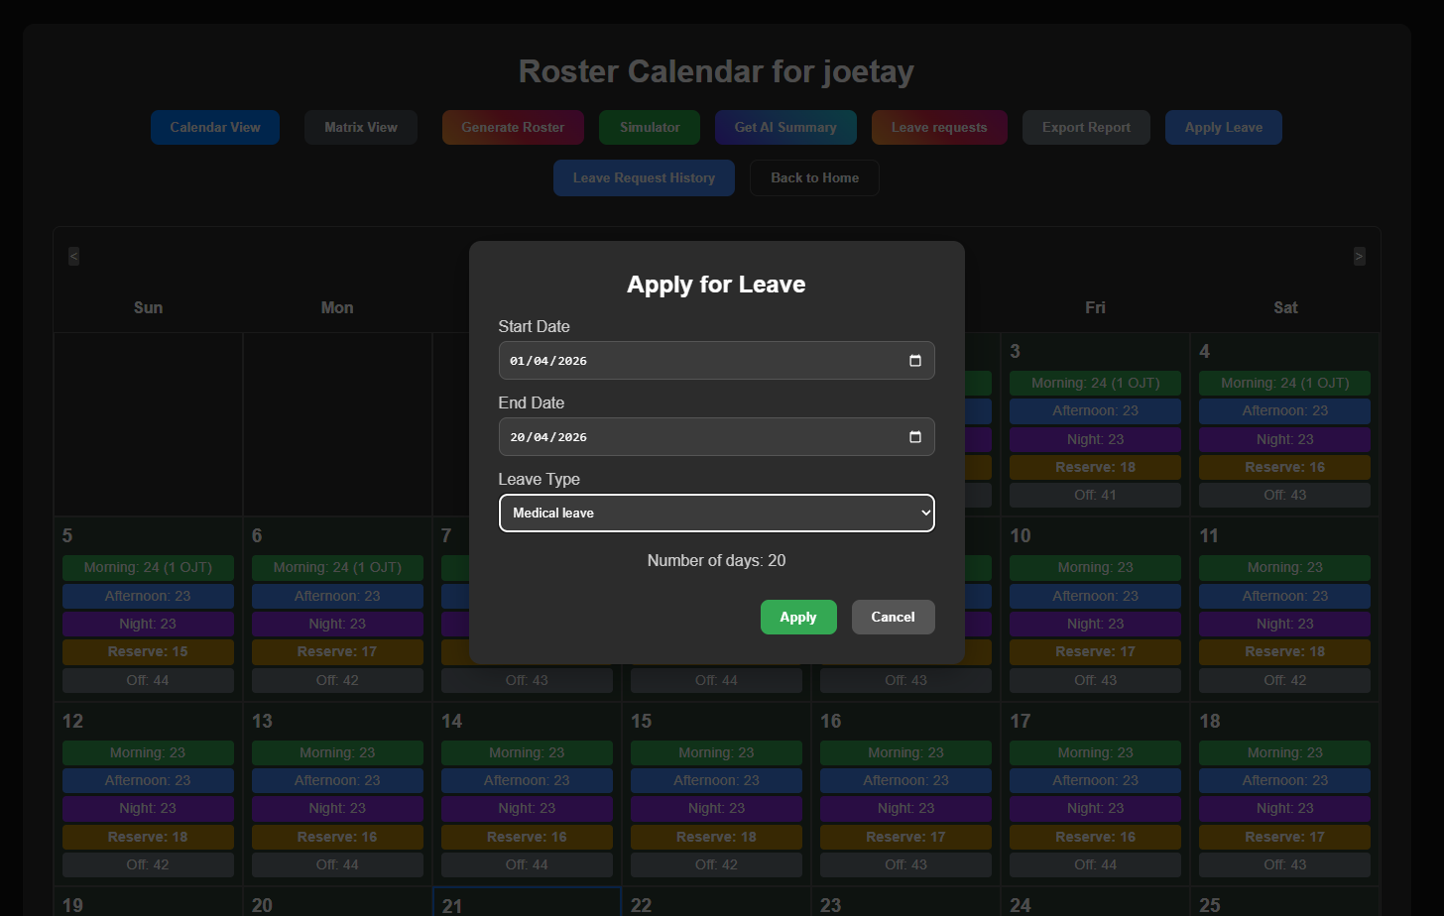
## Block and Advance Leave Management
The "Block Leaves" section is for managing long-term or advance leave. For staff, click "Apply Block / Advance Leave," select the **Type**, the **Date Range**, and enter any **Remarks**. For Planners, the "Leave Applications" button opens a list of pending requests where you can review details and click "Approve" or "Reject." If rejecting, you must enter a **Rejection Reason** in the provided text box so the staff member understands the decision.

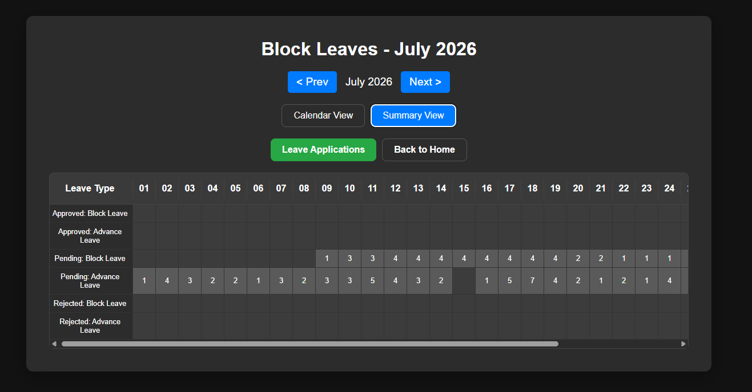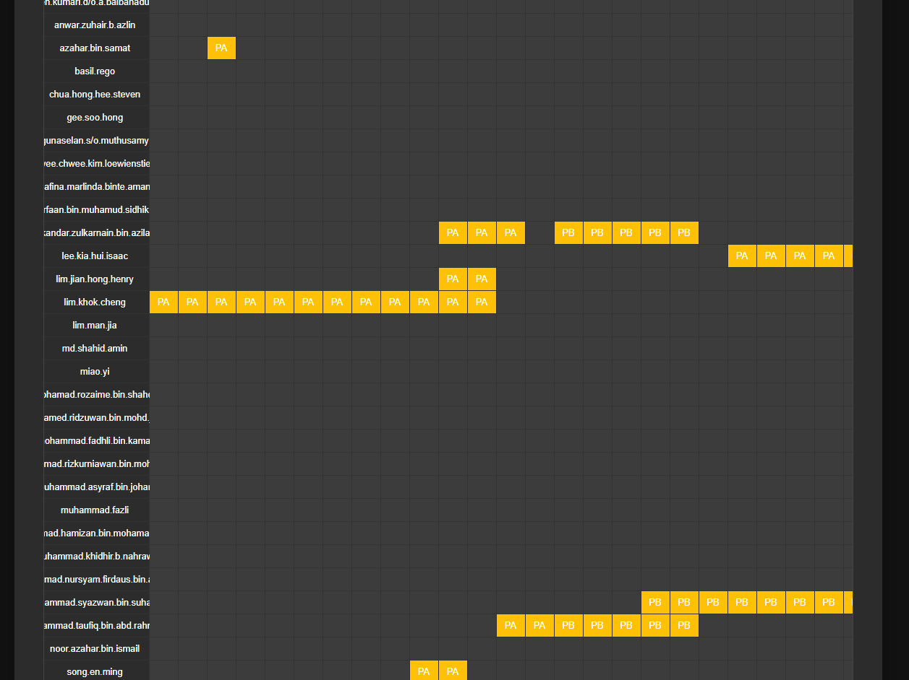
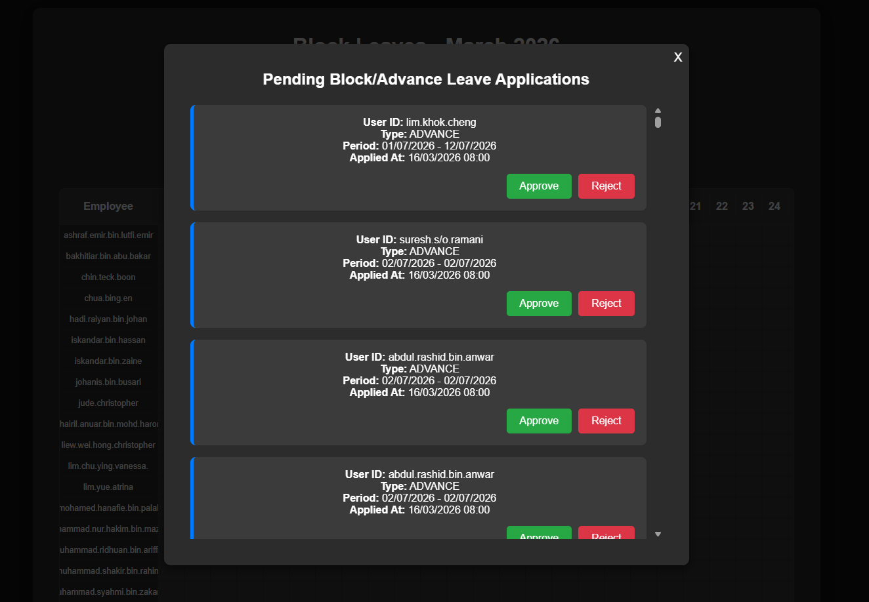
## Managing Workers (Planner Only)
To update the staff directory, click "Manage Workers" in the sidebar. To add a new person, go to the "Add" tab and enter their **User ID**, **Password**, **Team Number** (1-9), **Account Type** (Planner/Non-Planner), and **Proficiency Grade** (1-9). Use the "Modify" tab to update existing details by entering the **User ID to Modify** and changing only the necessary fields. To remove staff, use the "Delete" tab and enter the **User ID to Delete**.
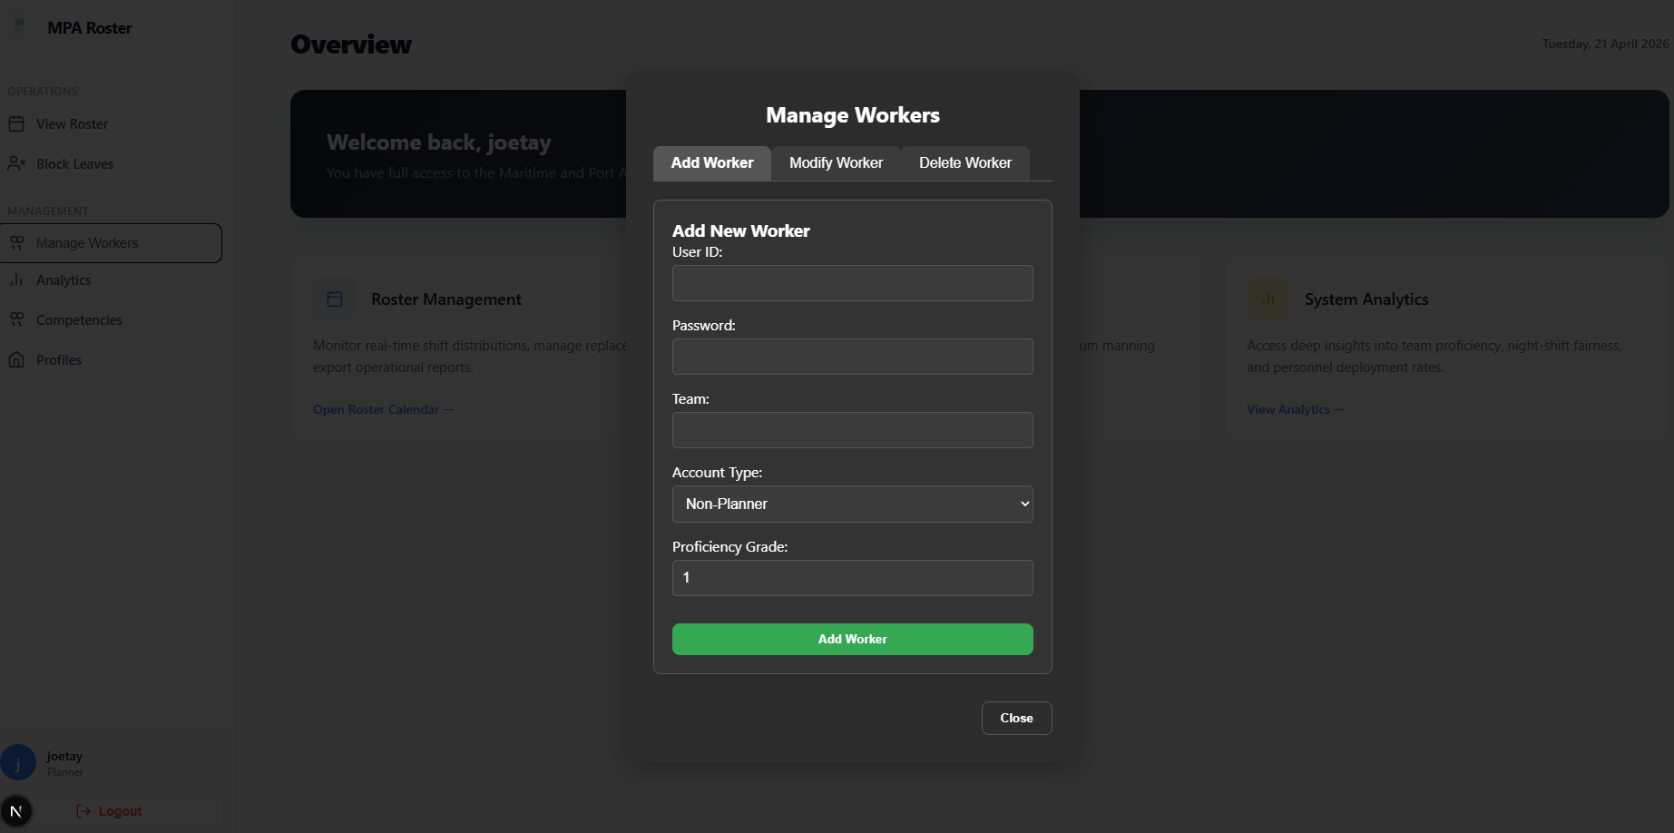
## Staff Competencies Matrix (Planner Only)
The "Competencies" page provides a detailed view of staff skills. Use the "Team Breakdown" tab to see which consoles each staff member is qualified for (indicated by a checkmark). Click on a checkmark to see the **Grade** and **Date Achieved**. Use the "Modify Competency" button to update a staff member's skill level by selecting their **User ID**, the **Console**, the new **Grade**, and the **Date**. The "OJT" tab tracks progress for trainees; use "Modify OJT" to update the **Number of Shifts** completed.
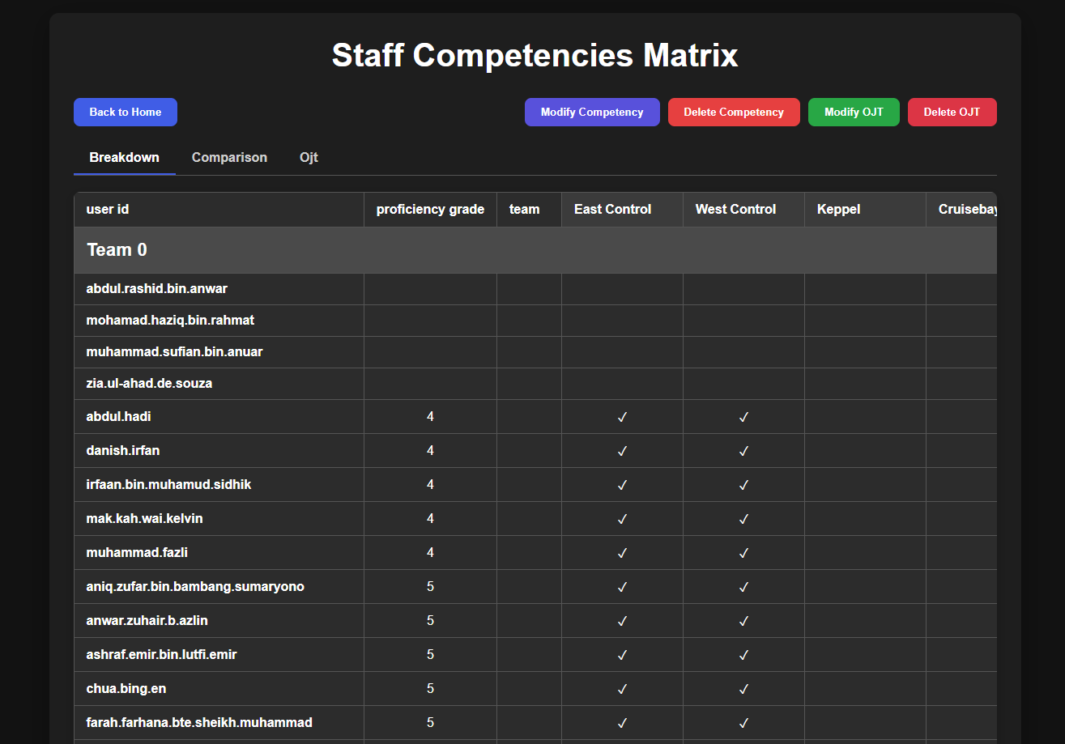
## Staff Profiles and Directory
To view a detailed history of a specific staff member, go to "Staff Profiles." Type a **User ID** or **Name** into the search box and select the correct person from the suggestions. The profile displays their **Account Type**, **Proficiency Grade**, and **Team**, along with a 3-month analysis of their **Deployment Distribution** (percentage of time spent on different consoles) and **Leave Analysis** (total days taken for each leave type).
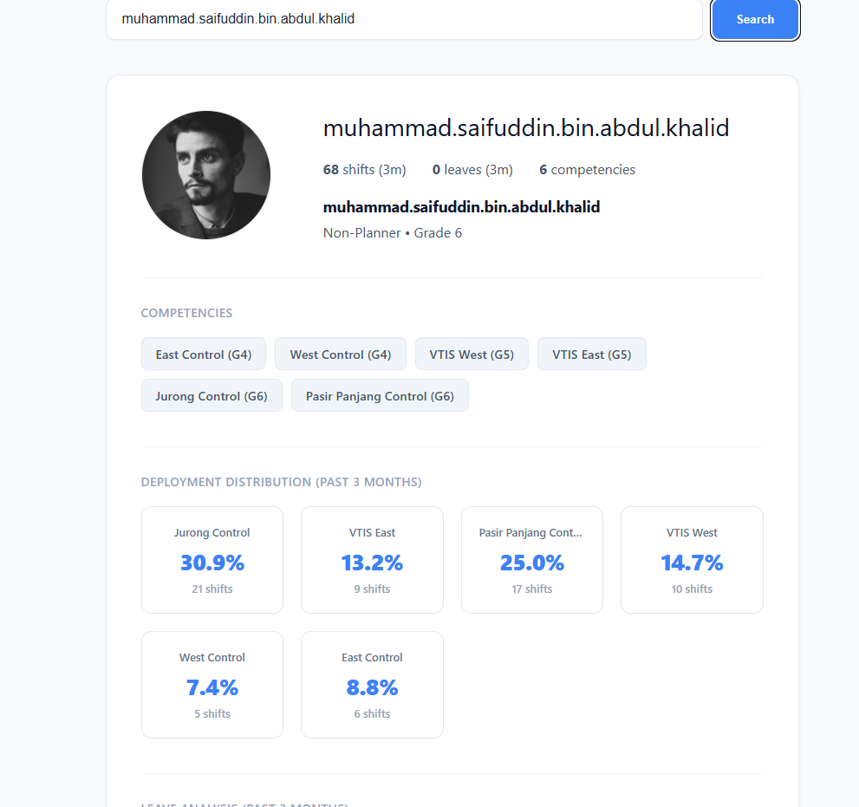
## System Analytics (Planner Only)
The "Analytics" page provides high-level insights into operations. Use the **Year** dropdown to filter all charts. For the "Night Shift Distribution" chart, input a specific **Start Date** and **End Date** to see how fairly night shifts are distributed among staff. Other charts like "Monthly Leave Applications," "Workforce Structure," and "Deployment Rate" help you understand staffing trends and ensure you have enough qualified personnel for all operational needs.
